Tender Document

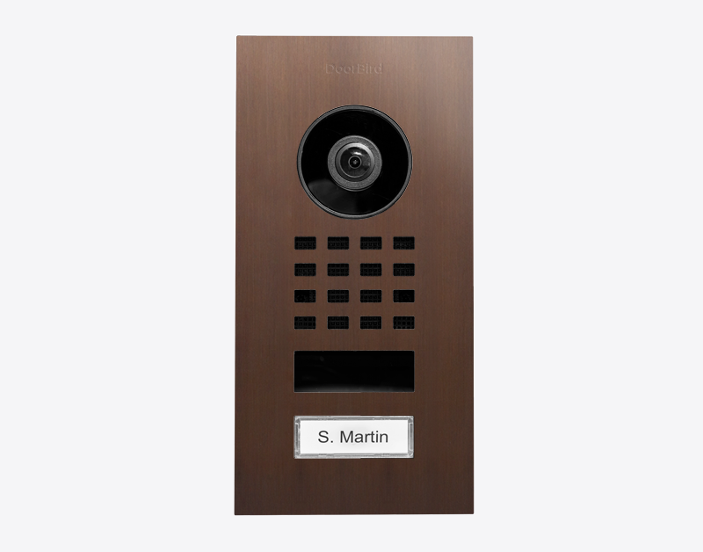

Product Name
D1101V Flush-mount IP Video Door Station

Short Description
For single-family homes and businesses with 1 unit, 1 call button

Product Description
- Flush-mounting housing included
- WiFi / LAN connection (PoE capable)
- 2-way audio
- Ultra-wide angle lens, 1080p, night vision, IR LEDs
- 4D motion sensor
- 1 freely configurable bistable switching relay

Highlights and Details
- Open API Local interface for integration with third-party systems and SIP
- Video and audio call On smartphones, tablets (iOS, Android), IP and landline phones (SIP)
- Smart Transmission Mode (STM) Real-time audio / video communication, optimized for mobile devices via WiFi, 3G, 4G, 5G
- Smart Home & NVR compatible Control4, Loxone, Crestron, Synology, AVM FRITZ!Fon, URC, QNAP, RTI, ELAN, Fibaro, Bang & Olufsen and others
- Microphone Clear voice transmission
- Automatic door buzzer For use in medical offices and office environments
- Free visitor history Store still images for free, optional video recording available
- Individual action schedules, e.g.: Switch relay 1 for automatic door release Mon-Fri from 9 am until 4 pm when the call button is pressed 4D motion sensor switches on external lamp between 9 pm and 6 am
- Geofencing Automatic door and gate opening when returning home
- Night vision With Infrared LEDs
- HDTV Video Ultra wide-angle, hemispheric lens, 180°
- Light sensor For night vision mode
- One freely configurable bistable latching relay Control one door or one gate via App Status configurable via App: temporary or permanent circuit
- Easy self-install Quick installation via QR code scan
- Call button With backlit nameplate
- Motion sensor with 4D technology Distance up to 6 m (19.7 ft) adjustable via App (interval: 1 m/ 3.3 ft)
- Noise reduction and echo cancellation (AEC, ANR)
- Easy connection to the network Connection via a network cable or bell wire via 2-Wire Ethernet PoE Converter “DooBird A1071” (PoE, network data)
- WiFi enabled Works within a WiFi network, no LAN cable needed
- Bluetooth Low Energy (BLE) For access control, compatible external sensors and smart locks

Product Weight
1355 gm

Delivery time
Delivery within 6 business days!

Datasheet
datasheet_d1101v_flush_en.pdf (doorbird.com)

Often Ordered As Well
- IP Video Indoor Station A1101 White Edition
- IP Video Indoor Station A1101 Black Edition
- IP I/O Door Controller A1081
- 2-wire Ethernet PoE Converter A1071
- D11x Nameplate for call button, individual engraving

