**Tender Document**

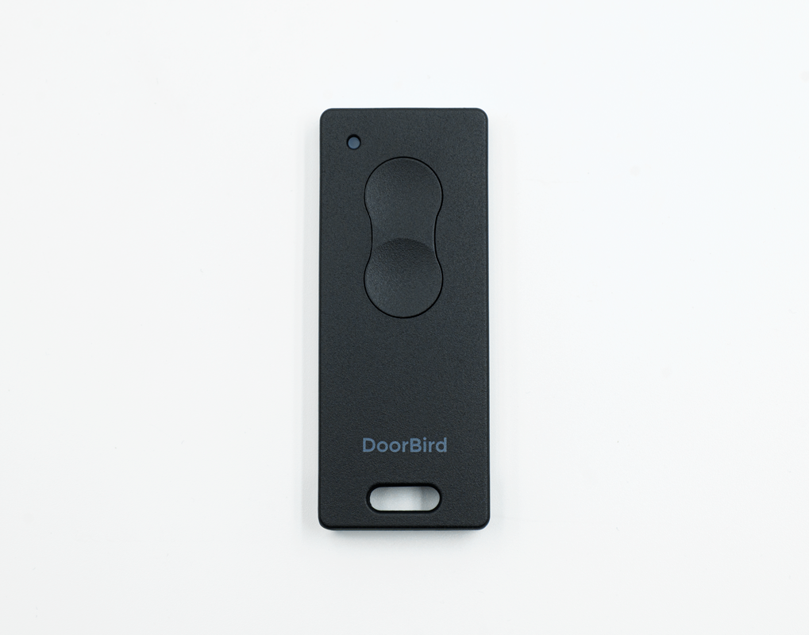

**Product Name**

Bluetooth Keyfob Remote A8007

**Short Description**

Identification and contact-free access via Bluetooth

**Product Description**

* Remote control with two freely programmable keys
* For single-family, multi-tenant and commercial residences
* For residential and commercial use
* Flexibly manage permissions and times
* Dust-proof and water-proof for high durability
* Compact format and robust aluminium frame
* Individually configurable with compatible DoorBird units
* Battery type CR1632 not included
* Compatible with DoorBird D11x, A1121, A1122 and D1812 series

**Highlights and Details**

* 2 freely programmable keys for door and gate opening, light, elevator and many more Requires appropriate on-site interfaces for connection to the DoorBird relay or processing of HTTP(s) commands
* Dust-, water-, and shock-resistant  According to IP56 standard
* Button events, authorizations and time profiles  can be set individually via the DoorBird app
* Button events Switching of integrated (D11x, A1121, A1122, D1812) and separate (A1081) DoorBird relays or sending of HTTP(s) commands to control external systems
* Robust and small With a frame made of high quality aluminum
* Usable at all entrances and buildings with compatible DoorBird units Individually configurable
* Practical to pass on E.g. to friends, relatives, service providers, property managers, or tenants
* Multicolor status LED Gives feedback whether the button command was successfully sent
* Easy configuration and management Via the DoorBird App
* Car mount for sun visor Included in the scope of delivery
* In case of loss, the Bluetooth Keyfob Remote can be deleted directly via the app

**Product Weight**

150 gm

**Delivery time**

Delivery within 6 business days!

**Datasheet**

[https://www.doorbird.comdatasheet_a8007_en.pdf (doorbird.com)](https://doorbird.comhttps://www.doorbird.com/downloads/datasheet/datasheet_a8007_en.pdf)

**Often Ordered As Well**

* D1101V Surface-mount IP Video Door Station
* D1101V Flush-mount IP Video Door Station
* D1102V Surface-mount IP Video Door Station
* D1102V Flush-mount IP Video Door Station
* D1101FV Fingerprint 50 Surface-mount IP Video Door Station
* D1101FV Fingerprint 50 Flush-mount IP Video Door Station
* D1102FV Fingerprint 50 Surface-mount IP Video Door Station
* D1102FV Fingerprint 50 Flush-mount IP Video Door Station
* A1121 Surface-mount IP Access Control Device
* A1121 Flush-mount IP Access Control Device