**Tender Document**

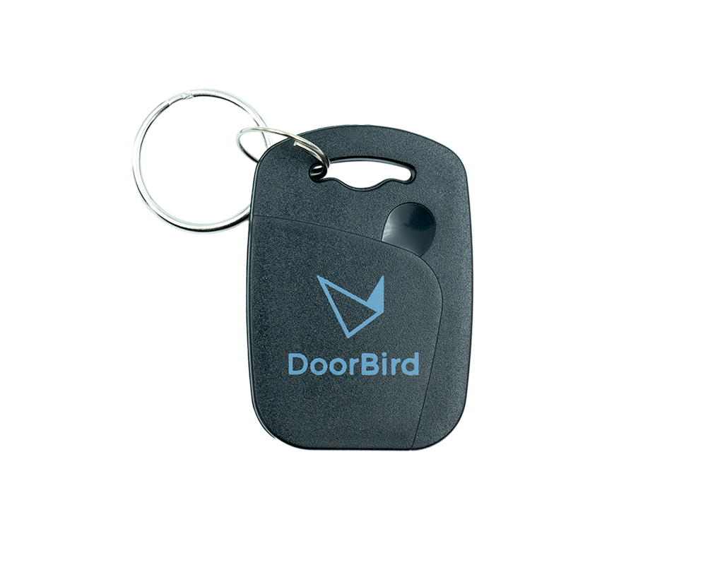

**Product Name**

Dual-Frequency RFID Transponder Key Fob A8005, 10 p.

**Product Description**

* 125 KHz (EM4100) and 13.56 MHz (MIFARE® DESFire® EV2 8K)
* For A1121 IP Access Control Device
* For D1812 IP Video Door Station
* For D21x IP Video Door Stations and later
* Material: ABS, waterproof, black
* 10 pieces

**Product Weight**

56 gm

**Delivery time**

Delivery within 6 business days!

**Datasheet**

[datasheet_keyfob2_en.pdf (doorbird.com)](https://doorbird.com/downloads/datasheet/datasheet_keyfob2_en.pdf)

**Often Ordered As Well**

* A1121 Surface-mount IP Access Control Device
* A1121 Flush-mount IP Access Control Device