**Tender Document**

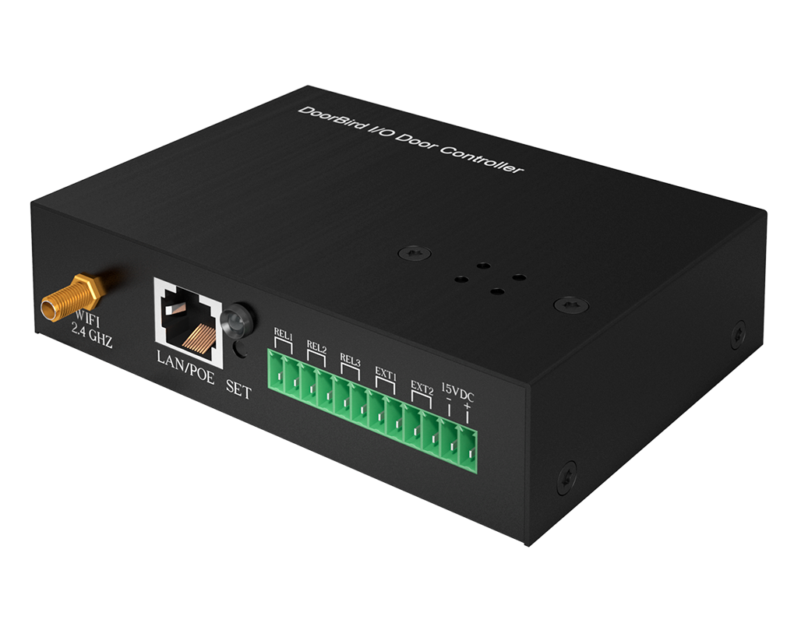

**Product Name**

IP I/O Door Controller A1081

**Short Description**

For tamperproof control of up to 3 doors or gates

**Product Description**

* Supports WiFi, Ethernet, PoE
* Encryption based on banking standards
* Monitoring of 2 external sensors
* 3 freely configurable, bistable switching relays
* Mounting on walls, ceilings and in control cabinets

**Highlights and Details**

* Tamperproof control of up to three doors or gates
* Encryption based on banking standard
* Monitoring of two external sensors
* Three freely configurable, bi-stable switching relays (permanently open, permanently closed, toggle)
* The switching relays keep their state even in the case of loss of power
* Wireless network, Ethernet, PoE
* Alarm notification via push notification on smartphone and tablet
* Can be mounted on walls, ceilings or in control cabinets

**Product Weight**

670 gm

**Delivery time**

Delivery within 6 business days!

**Often Ordered As Well**

* IP Door Chime A1061W
* A1121 Surface-mount IP Access Control Device
* A1121 Flush-mount IP Access Control Device