**Tender Document**

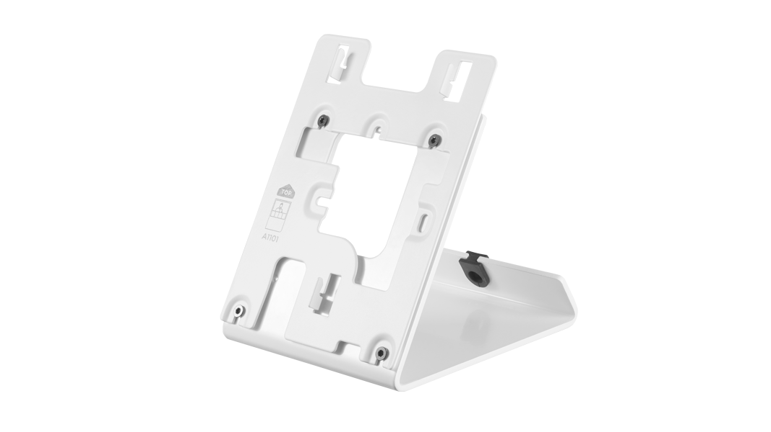

**Product Name**

Table-stand A8003 White Edition

**Product Description**

* For IP Video Indoor Station A1101

**Product Weight**

890 gm

**Delivery time**

Delivery within 6 business days!

**Datasheet**

[datasheet_a8003_white_en.pdf (doorbird.com)](https://doorbird.com/downloads/datasheet/datasheet_a8003_white_en.pdf)

**Often Ordered As Well**

* IP Video Indoor Station A1101 White Edition
* D2101V IP Video Door Station
* D1101V Flush-mount IP Video Door Station