**Tender Document**

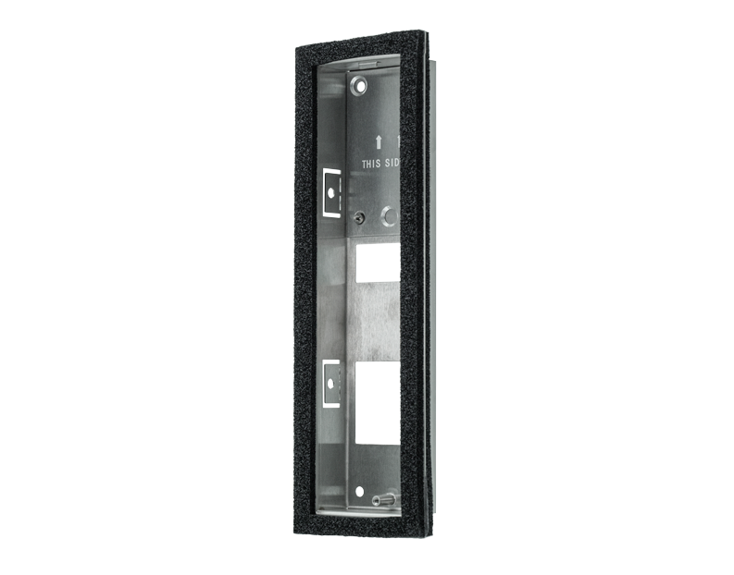

**Product Name**

D1102FV Fingerprint 50/D1101KV Flush-mounting housing (Backbox)

**Short Description**

Stainless Steel V2A

**Product Description**

* Fits only a D1102FV/D1101KV IP Video Door Station

**Product Weight**

675 gm

**Delivery time**

Delivery within 6 business days!

**Datasheet**

[datasheet_d1102fv50_flush_housing_en.pdf (doorbird.com)](https://doorbird.com/downloads/datasheet/datasheet_d1102fv50_flush_housing_en.pdf)

**Often Ordered As Well**

* D1102FV Fingerprint 50 Flush-mount IP Video Door Station
* D1101KV Flush-mount IP Video Door Station