**Tender Document**

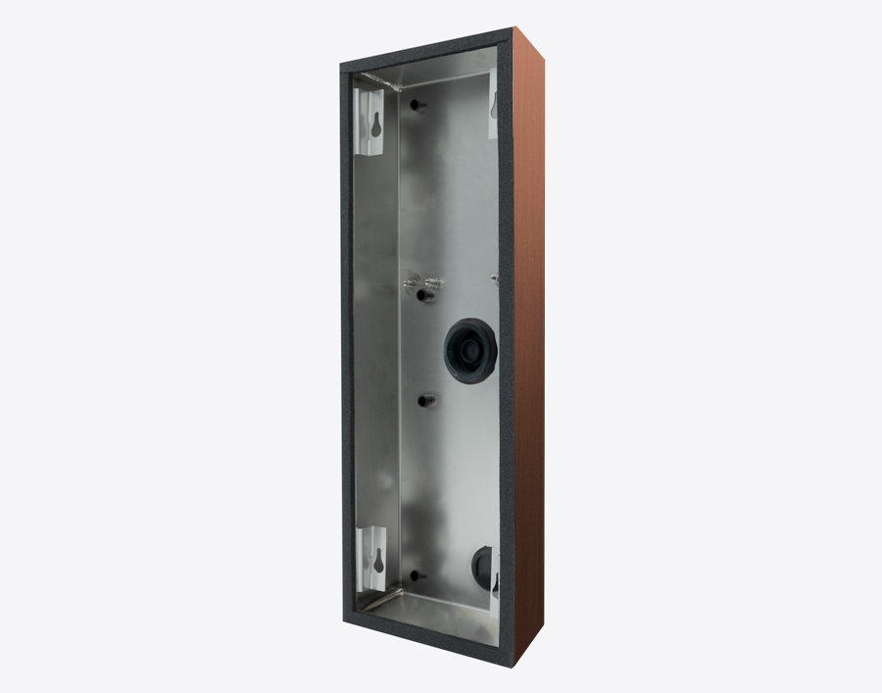

**Product Name**

D2101KV, D2102FV Fingerprint 50, D2102FV EKEY, D2101FV EKEY sLine, D2102FV EKEY sLine Surface-mounting housing (Backbox)

**Product Description**

* Fits only the following IP Video Door Stations:
* D2101KV
* D2102FV Fingerprint 50
* D2102FV ekey
* D2101FV ekey sLine
* D2102FV ekey sLine

**Product Weight**

677 gm

**Delivery time**

Delivery within 6 business days!

**Datasheet**

[/downloads/datasheet_d2101kv_surface_en.pdf (doorbird.com)](https://doorbird.com/downloads/datasheet_d2101kv_surface_en.pdf)

**Often Ordered As Well**

* D2101KV IP Video Door Station
* D2102FV Fingerprint 50 IP Video Door Station
* D2102FV EKEY IP Video Door Station