**Tender Document**

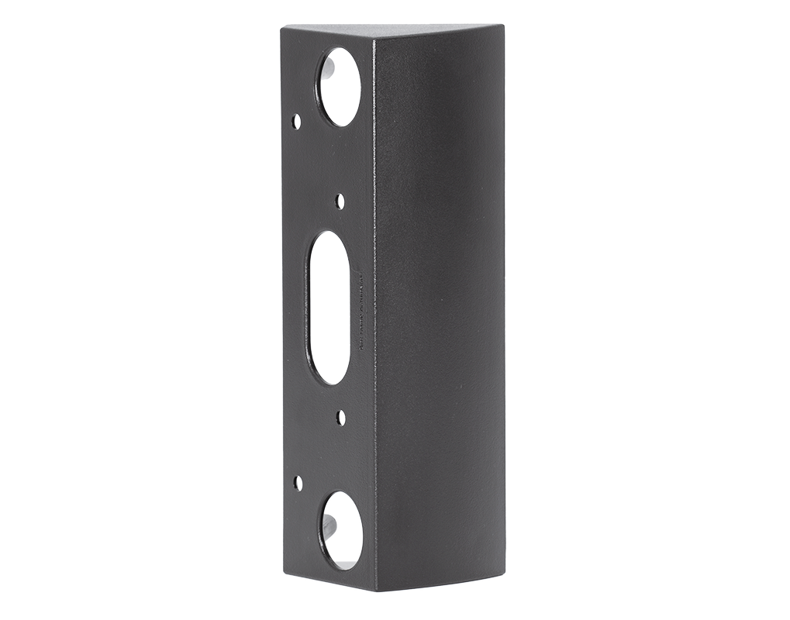

**Product Name**

Angle corner wall-mount adapter A8002

**Short Description**

Polycarbonate

**Product Description**

* Fits only D1101V and D1102V Surface-Mount IP Video Door Stations
* Angle: 45° horizontal left or right

**Product Weight**

150 gm

**Delivery time**

Delivery within 4 business days!

**Datasheet**

[datasheet_a8002_en.pdf (doorbird.com)](https://doorbird.com/downloads/datasheet/datasheet_a8002_en.pdf)

**Often Ordered As Well**

* Wedge corner wall-mount adapter A8001
* D1101V Surface-mount IP Video Intercom