**Tender Document**

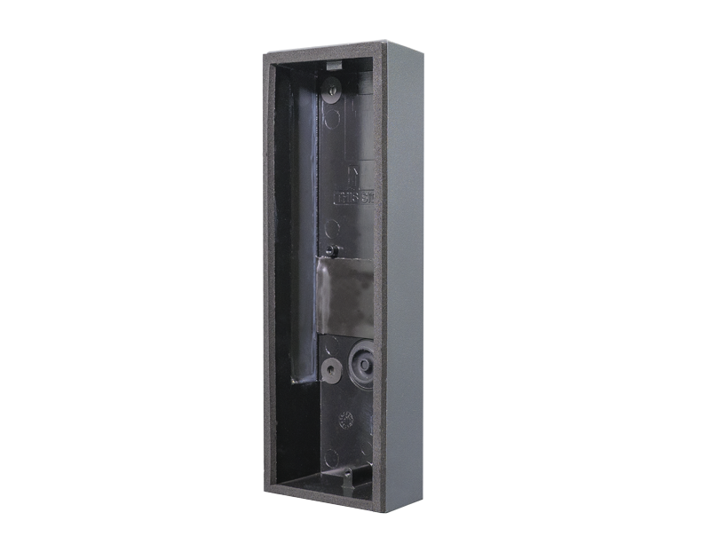

**Product Name**

D1102V Surface-mounting housing (Backbox)

**Short Description**

Polycarbonate

**Product Description**

* Fits only a D1102V IP Video Door Station

**Product Weight**

225 gm

**Delivery time**

Delivery within 6 business days!

**Datasheet**

[datasheet_d1102v_surface_housing_en.pdf (doorbird.com)](https://doorbird.com/downloads/datasheet/datasheet_d1102v_surface_housing_en.pdf)

**Often Ordered As Well**

* D1102V Surface-mount IP Video Door Station