**Tender Document**

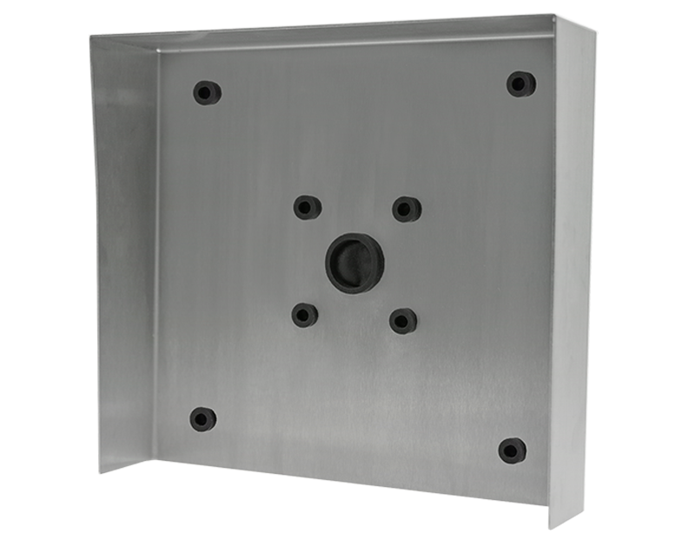

**Product Name**

D2101KH, D2101IKH, D21DKH Protective hood

**Short Description**

Stainless steel V4A (salt-water and grinding dust resistant)

**Product Description**

* Fits only the following IP Video Door Stations:
* D2101KH
* D2101IKH
* D21DKH

**Product Weight**

2150 gm

**Delivery time**

Delivery within 4 business days!

**Often Ordered As Well**

* D2101KH IP Video Intercom
* D2101IKH IP Video Intercom
* D21DKH IP Video Door Station