**Tender Document**

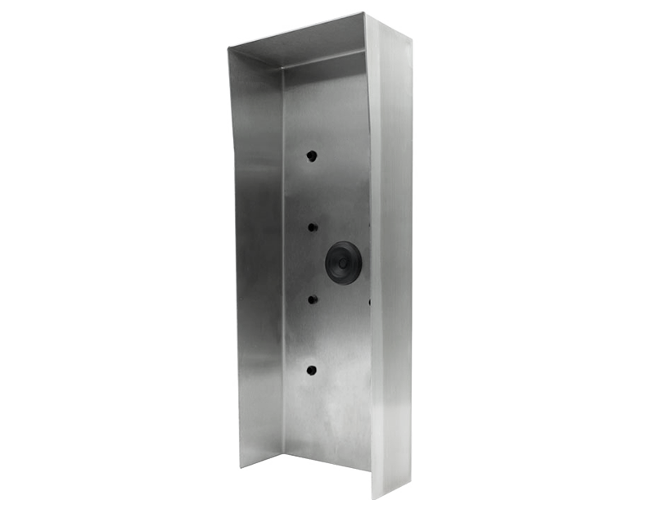

**Product Name**

D2101KV, D2102FV FINGERPRINT 50, D2101FV ekey, D2101FV ekey sLine, D2102FV ekey sLine Protective Hood

**Short Description**

Stainless steel V4A (salt-water and grinding dust resistant)

**Product Description**

* Fits only the following IP Video Door Stations:
* D2101KV
* D2102FV Fingerprint 50
* D2102FV ekey
* D2101FV ekey sLine
* D2102FV ekey sLine

**Product Weight**

2000 gm

**Delivery time**

Delivery within 4 business days!

**Datasheet**

[/downloads/datasheet_d2101kv_protectivehood_en.pdf (doorbird.com)](https://doorbird.com/downloads/datasheet_d2101kv_protectivehood_en.pdf)

**Often Ordered As Well**

* D2101KV IP Video Intercom
* D2102FV Fingerprint 50 IP Video Door Station
* D2102FV EKEY IP Video Door Station