**Tender Document**

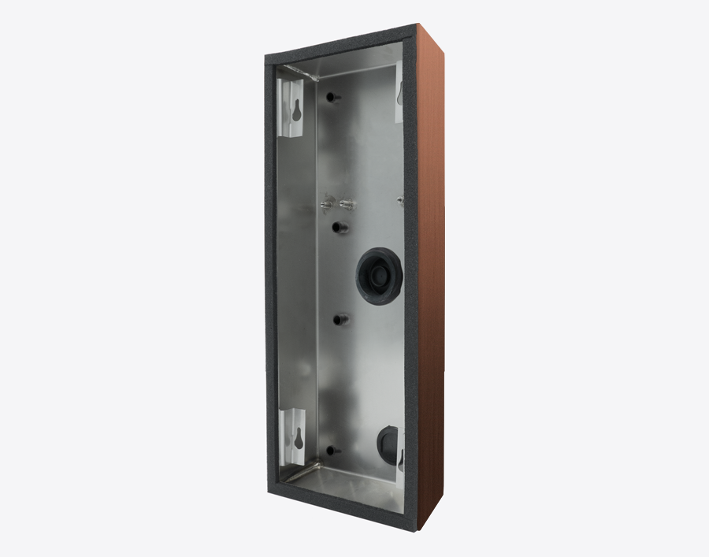

**Product Name**

D2102V/D2103V/D2101FV Fingerprint 50/D2101FV EKEY/D2101TFV Surface-mounting housing (Backbox)

**Short Description**

Stainless steel V4A (salt-water and grinding dust resistant)

**Product Description**

* Fits only D2102V/D2103V/D2101FV Fingerprint 50/D2101FV EKEY/D2101TFV IP Video Door Stations

**Product Weight**

875 gm

**Delivery time**

Delivery within 6 business days!

**Datasheet**

[/downloads/datasheet_d2102-3v_surface_en.pdf (doorbird.com)](https://doorbird.com/downloads/datasheet_d2102-3v_surface_en.pdf)

**Often Ordered As Well**

* D2102V IP Video Door Station
* D2103V IP Video Door Station
* D2101FV Fingerprint 50 IP Video Door Station
* D2101FV EKEY IP Video Door Station