**Tender Document**

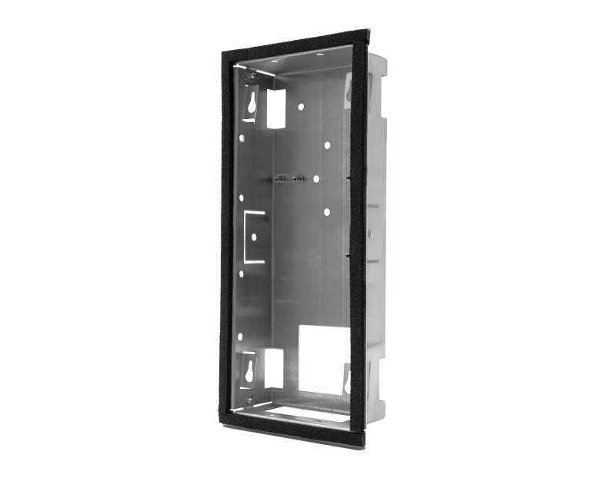

**Product Name**

D2102V/D2103V/D2101TFV/D2101FV Fingerprint 50/D2101FV EKEY Flush-mounting housing (Backbox)

**Product Weight**

440 gm

**Delivery time**

Delivery within 6 business days!

**Often Ordered As Well**

* D2102V IP Video Door Station
* D2103V IP Video Door Station
* D2101FV Fingerprint 50 IP Video Door Station
* D2101FV EKEY IP Video Door Station
* D2101TFV IP Video Door Station