**Tender Document**

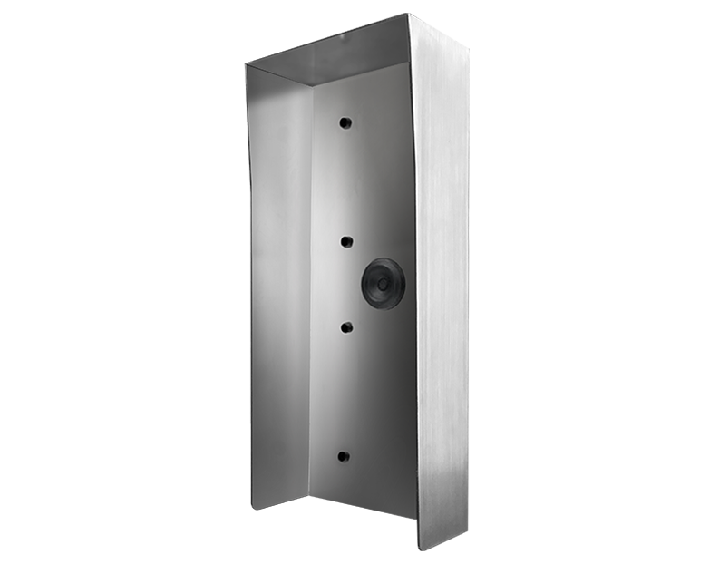

**Product Name**

D2102V, D2103V, D2101FV Fingerprint 50, D2101FV EKEY, D2101TFV Protective hood

**Short Description**

Stainless steel V4A (salt-water and grinding dust resistant)

**Product Description**

* Fits only the following IP Video Door Stations:
* D2102V
* D2103V
* D2101FV Fingerprint 50
* D2101FV EKEY
* D2101TFV

**Product Weight**

1800 gm

**Delivery time**

Delivery within 4 business days!

**Datasheet**

[/downloads/datasheet_d2102v_protectivehood_en.pdf (doorbird.com)](https://doorbird.com/downloads/datasheet_d2102v_protectivehood_en.pdf)

**Often Ordered As Well**

* D2102V IP Video Intercom
* D2103V IP Video Intercom
* D2101FV Fingerprint 50 IP Video Intercom
* D2101FV EKEY IP Video Intercom