**Tender Document**

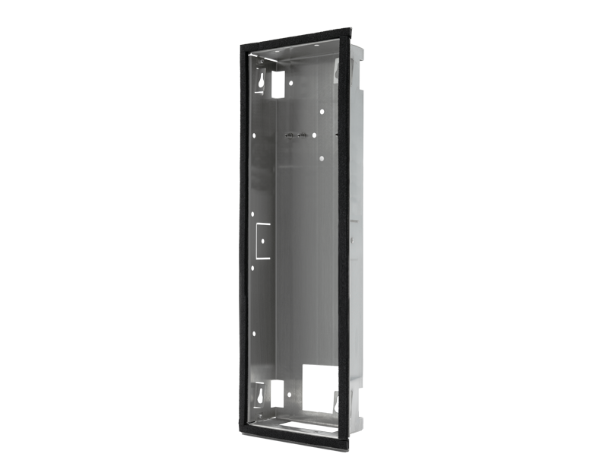

**Product Name**

D2104V/D2105V/D2106V Flush-mounting housing (Backbox)

**Short Description**

Stainless Steel V2A

**Product Description**

* Fits only D2104V/D2105V/D2106V EKEY IP Video Door Stations

**Product Weight**

650 gm

**Delivery time**

Delivery within 6 business days!

**Datasheet**

[/downloads/datasheet_d2104v_flush_en.pdf (doorbird.com)](https://doorbird.com/downloads/datasheet_d2104v_flush_en.pdf)

**Often Ordered As Well**

* D2104V IP Video Door Station
* D2105V IP Video Door Station
* D2106V IP Video Door Station