**Tender Document**

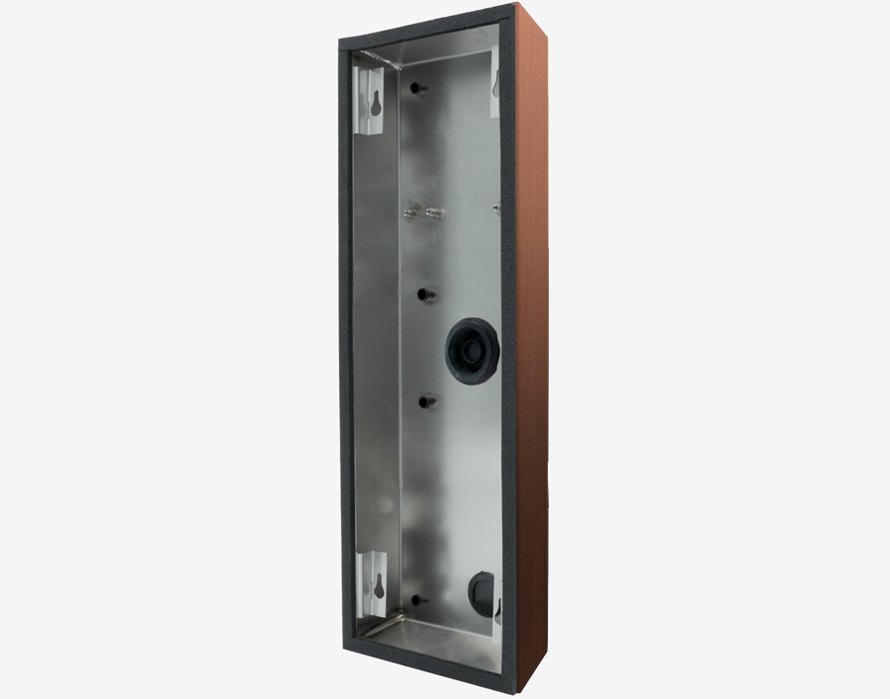

**Product Name**

D2104V/D2105V/D2106V Surface-mounting housing (Backbox)

**Short Description**

Stainless Steel V2A

**Product Description**

* Fits only D2104V/D2105V/D2106V IP Video Door Stations

**Product Weight**

1350 gm

**Delivery time**

Delivery within 6 business days!

**Datasheet**

[datasheet_d2104-6v_housing_en.pdf (doorbird.com)](https://doorbird.com/downloads/datasheet/datasheet_d2104-6v_housing_en.pdf)

**Often Ordered As Well**

* D2104V IP Video Door Station
* D2105V IP Video Door Station
* D2106V IP Video Door Station