**Tender Document**

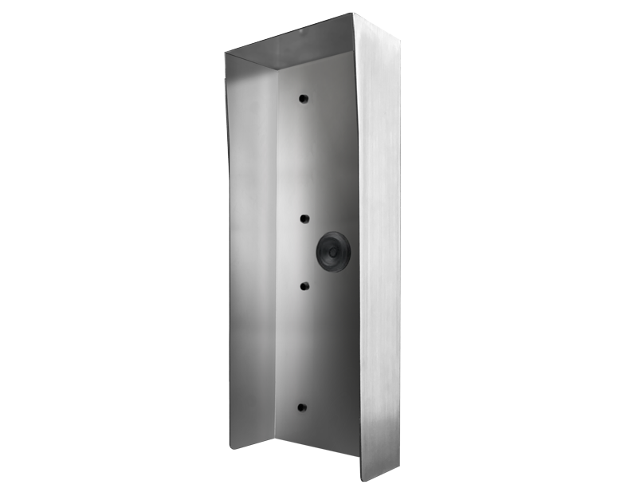

**Product Name**

D2104V, D2105V, D2106V Protective hood

**Short Description**

Stainless steel V4A (salt-water and grinding dust resistant)

**Product Description**

* Fits only the following IP Video Door Stations:
* D2104V
* D2105V
* D2106V

**Product Weight**

2085 gm

**Delivery time**

Delivery within 4 business days!

**Datasheet**

[/downloads/datasheet_d2104v_protectivehood_en.pdf (doorbird.com)](https://doorbird.com/downloads/datasheet_d2104v_protectivehood_en.pdf)

**Often Ordered As Well**

* D2104V IP Video Intercom
* D2105V IP Video Intercom
* D2106V IP Video Intercom