**Tender Document**

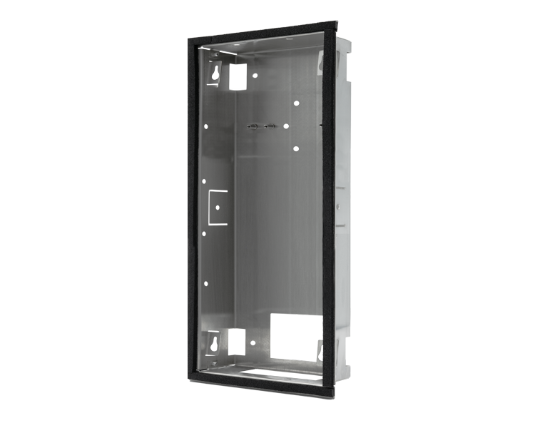

**Product Name**

D2115V/D2116V/D2117V/D2118V Flush-mounting housing (Backbox)

**Short Description**

Stainless Steel V2A

**Product Description**

* Fits only D2115V/D2116V/D2117V/D2118V IP Video Door Stations

**Product Weight**

650 gm

**Delivery time**

Delivery within 6 business days!

**Datasheet**

[datasheet_d2115-18v_flush_housing_en.pdf (doorbird.com)](https://doorbird.com/downloads/datasheet/datasheet_d2115-18v_flush_housing_en.pdf)

**Often Ordered As Well**

* D2115V IP Video Door Station
* D2116V IP Video Door Station
* D2117V IP Video Door Station
* D2118V IP Video Door Station