**Tender Document**

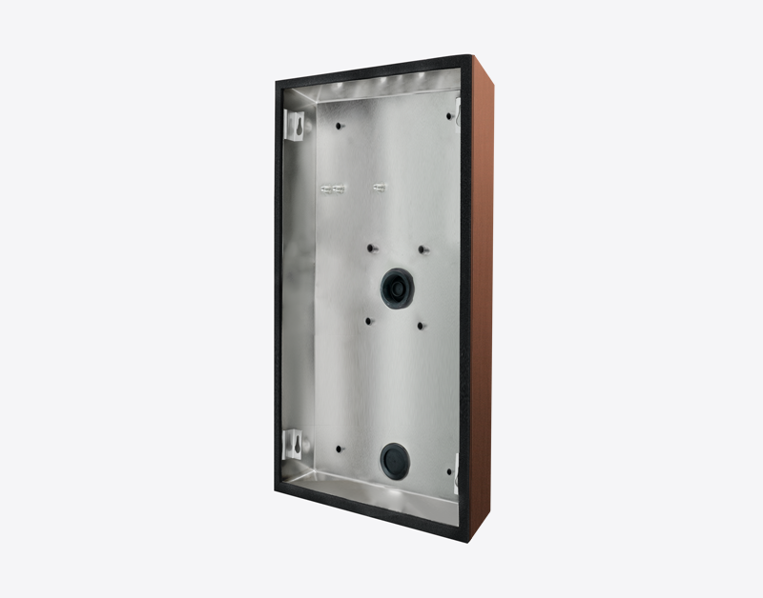

**Product Name**

D2115V/D2116V/D2117V/D2118V Surface-mounting housing (backbox)

**Short Description**

Stainless steel V4A

**Product Description**

* Fits only D2115V/D2116V/D2117V/D2118V IP Video Door Stations

**Product Weight**

1035 gm

**Delivery time**

Delivery within 12 business days!

**Datasheet**

[datasheet_d2115-18v_surface_housing_en.pdf (doorbird.com)](https://doorbird.com/downloads/datasheet/datasheet_d2115-18v_surface_housing_en.pdf)