**Tender Document**

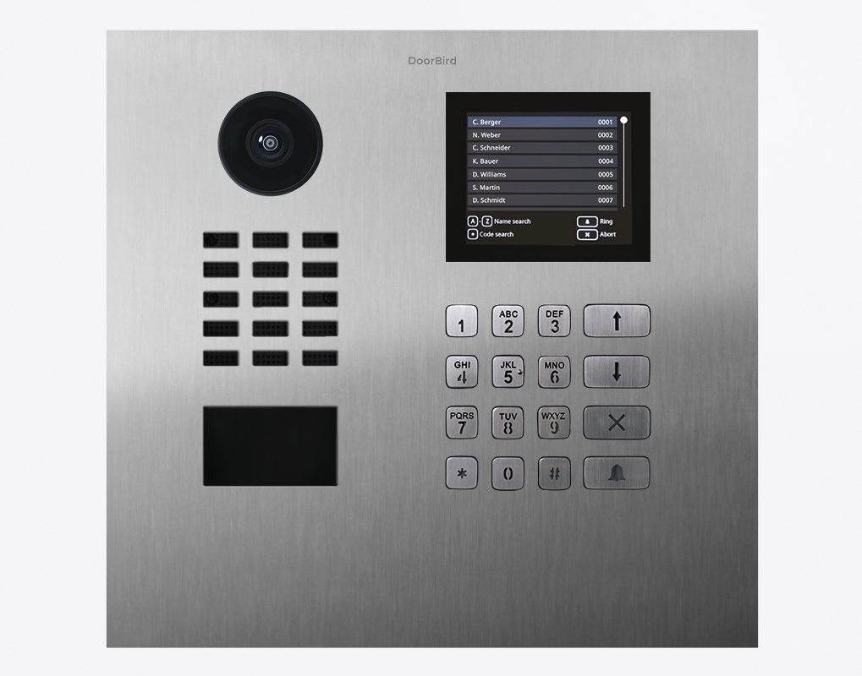

**Product Name**

D21DKH IP Video Door Station

**Short Description**

For multi-tenant residences and buildings with up to 500 units

**Product Description**

* Surface- and flush-mount possible, housings sold separately
* LAN connection (PoE capable)
* 2-way audio
* Ultra-wide angle lens, 720p, night vision, 12 IR LEDs
* 4D motion sensor, RFID reader
* Keypad, display module
* 2 freely configurable bistable switching relays

**Highlights and Details**

* Open API Local interface for integration with third-party systems and SIP
* Video and audio call On smartphones, tablets (iOS, Android), IP and landline phones (SIP)
* Smart Transmission Mode (STM) Real-time audio / video communication, optimized for mobile devices via WiFi, 3G, 4G, 5G
* Smart Home & NVR compatible Control4, Loxone, Crestron, Synology, AVM FRITZ!Fon, URC, QNAP, RTI, ELAN, Fibaro, Bang & Olufsen and others
* Automatic door buzzer For use in medical offices and office environments
* Free visitor history Store still images for free, optional video recording available
* Individual action schedules, e.g.: RFID card “abc” has only access on Wednesday from 9 am until 11 am
* Geofencing Automatic door and gate opening when returning home
* Night vision With 12 Infrared LEDs
* HDTV Video Ultra wide-angle, hemispheric lens, 180°
* Light sensor For night vision mode
* Microphone Clear voice transmission
* Noise reduction and echo cancellation (AEC, ANR)
* RFID reader Configurable remotely via App (e.g. time frame)
* Call button With backlit nameplate
* Easy connection to the network Connection via a network cable or bell wire via 2-Wire Ethernet PoE Converter “DooBird A1071” (PoE, network data)
* Two freely configurable bi-stable switching relays Two doors or gates can be controlled via App Status configurable via App: temporary or permanent circuit
* Keypad Module Configurable via App More than 500 individual PIN codes Individual events (e.g. trigger a relay, HTTP(s) request)
* Display Module Distance sensitivity on/off Individually configurable, e.g.: display of the resident directory, welcome message

**Product Weight**

3083 gm

**Delivery time**

Delivery within 6 business days!

**Datasheet**

[datasheet_d21dkh_02_en.pdf (doorbird.com)](https://doorbird.com/downloads/datasheet/datasheet_d21dkh_02_en.pdf)

**Required accessories**

* D21xKH Flush-mounting housing (Backbox)
* D21xKH Surface-mounting housing (Backbox)

**Often Ordered As Well**

* IP Video Indoor Station A1101 White Edition
* IP Video Indoor Station A1101 Black Edition
* IP I/O Door Controller A1081
* 2-wire Ethernet PoE Converter A1071
* D21xKH Protective hood