**Tender Document**

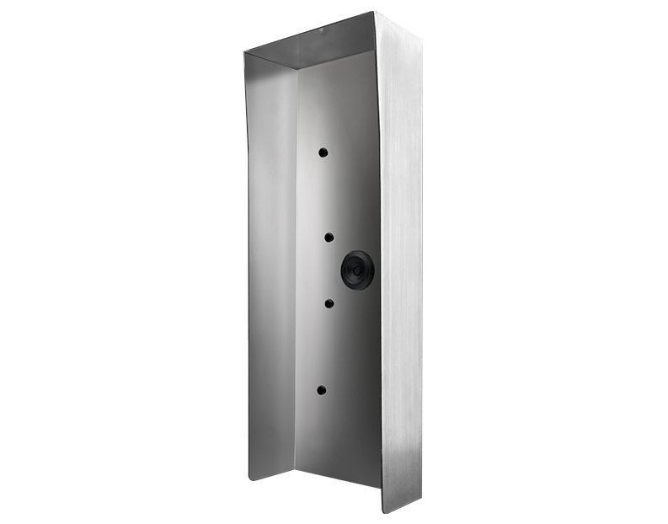

**Product Name**

D21DKV Protective hood

**Short Description**

Stainless steel V4A (salt-water and grinding dust resistant)

**Product Description**

* Fits only a D21DKV IP Video Door Station

**Product Weight**

2300 gm

**Delivery time**

Delivery within 4 business days!

**Often Ordered As Well**

* D21DKV IP Video Door Station