**Tender Document**

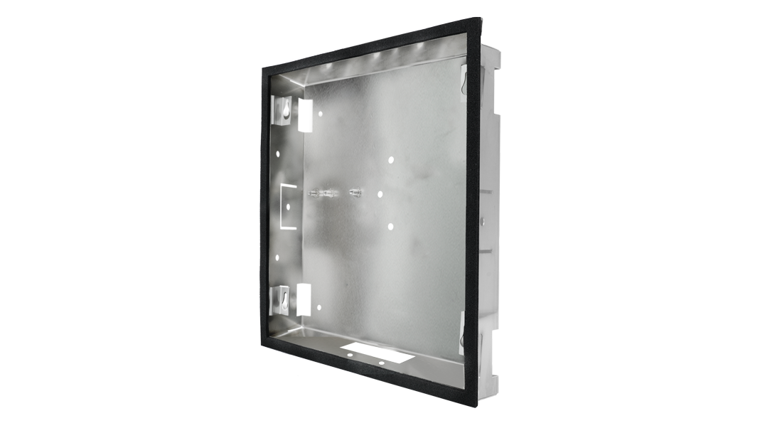

**Product Name**

D21xKH Flush-mounting housing (Backbox)

**Short Description**

Stainless Steel V2A

**Product Description**

* Fits only a D21xKH IP Video Door Station

**Product Weight**

772 gm

**Delivery time**

Delivery within 6 business days!

**Often Ordered As Well**

* D2101IKH IP Video Door Station
* D21DKH IP Video Door Station