**Tender Document**

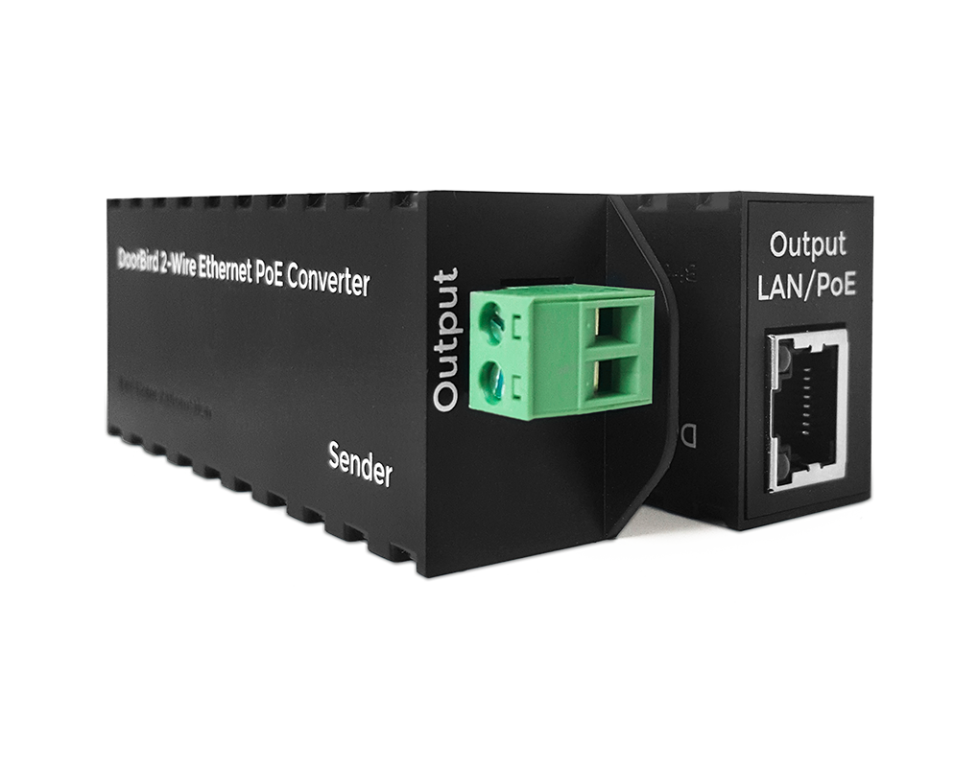

**Product Name**

2-wire Ethernet PoE Converter A1071

**Product Description**

* Ethernet including PoE over 2 wires
* Robust housing
* Transmission range: 80 m / 262 ft
* Up to 60 Mbit/s

**Highlights and Details**

* Use of existing cabling
* Only a two-wire cable required for both data transmission and power supply (PoE)
* Compact design, robust housing
* Easy and fast installation

**Product Weight**

330 gm

**Delivery time**

Delivery within 6 business days!

**Often Ordered As Well**

* IP Door Chime A1061W
* IP I/O Door Controller A1081