**Tender Document**

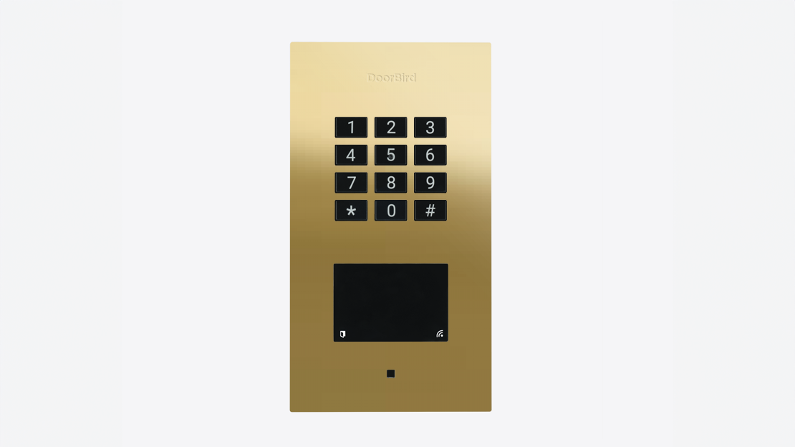

**Product Name**

A1121 Flush-mount IP Access Control Device

**Short Description**

Multi-technology access control system and stand-alone solution for back and side doors, garages, storage and packing rooms, bicycle and machine rooms

**Product Description**

* Flush-mount housing included
* WiFi / LAN connection (PoE capable)
* Keypad
* 125 KHz and 13.56 MHz RFID reader
* Tamper sensor
* Wiegand interface
* 2 freely configurable bistable switching relays

**Highlights and Details**

* Three separate access control devices combined: Keypad  RFID Reader Bluetooth low Energy (BLE)
* Keypad Module Configurable via App Up to 500 individual PIN codes Individual events (e.g. trigger a relay, HTTP(s) request)
* RFID sensor 125 KHz 13.56 MHZ
* Bluetooth low Energy (BLE) For access control, compatible external sensors and smart locks
* WiFi-capable
* Two freely configurable bistable switching relay
* Wiegand interface
* Manipulation sensor

**Product Weight**

1075 gm

**Delivery time**

Delivery within 50 business days!

**Datasheet**

[/downloads/datasheet_a1121_flush_en.pdf (doorbird.com)](https://doorbird.com/downloads/datasheet_a1121_flush_en.pdf)