**Tender Document**

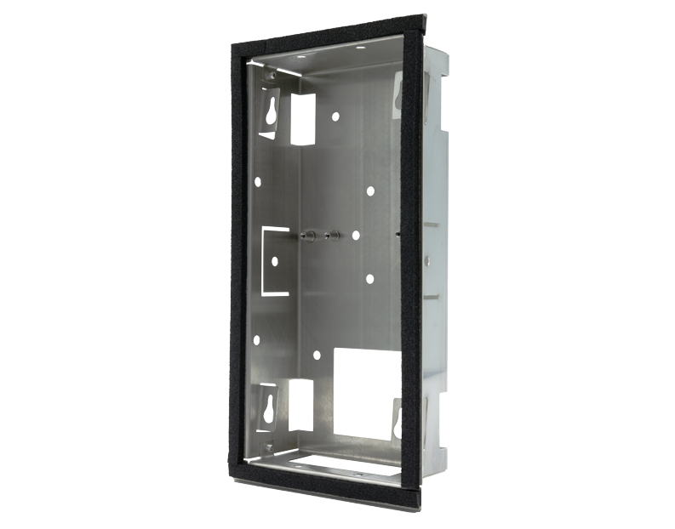

**Product Name**

D2101V Flush-mounting housing (Backbox)

**Short Description**

Stainless steel V2A

**Product Description**

* Fits only a D2101V IP Video Door Station

**Highlights and Details**

* stainless steel V2A

**Product Weight**

403 gm

**Delivery time**

Delivery within 6 business days!

**Often Ordered As Well**

* D2101V IP Video Door Station