**Tender Document**

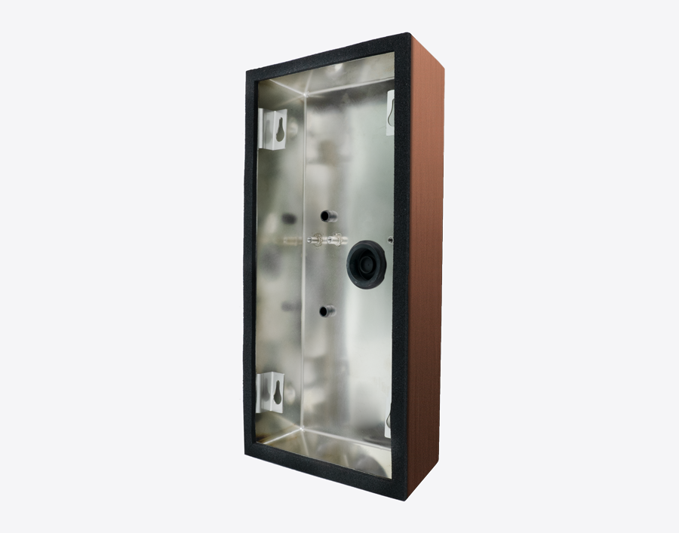

**Product Name**

D2101V Surface-mounting housing (Backbox)

**Short Description**

Stainless steel V4A (salt-water and grinding dust resistant)

**Product Description**

* Fits only a D2101V IP Video Door Station

**Product Weight**

515 gm

**Delivery time**

Delivery within 6 business days!

**Datasheet**

[/downloads/datasheet_d2101v_surface_en.pdf (doorbird.com)](https://doorbird.com/downloads/datasheet_d2101v_surface_en.pdf)

**Required accessories**

* D2101V IP Video Door Station

**Often Ordered As Well**