**Tender Document**

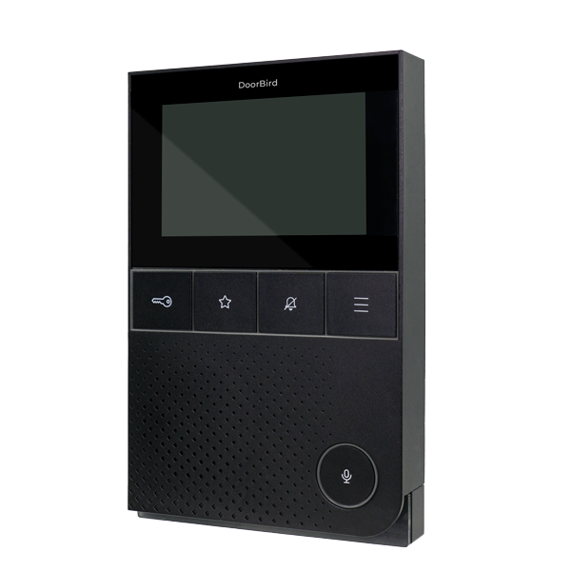

**Product Name**

IP Video Indoor Station A1101 Black Edition

**Short Description**

For door communication in single-family residences and apartment buildings

**Product Description**

* WiFi / LAN connection (PoE capable)
* 4“ True Color Touch Display
* 2-way HD Audio, up to 102 dB
* Room to room communication
* SIP support
* Home and building automation control
* 3 freely configurable bistable switching relays

**Highlights and Details**

* Benefits via IP Door opener and elevator control Visitor history (free Cloud Recording) Room to room communication, when using several Indoor Stations SIP support, e.g. for concierge or facility manager calls Weather forecast display Home and building automation control (IP, TCP, HTTPS, relays etc.) Configurable via the DoorBird App worldwide
* Intuitive User Interface 4“ True Color Touch Display Scratch-resistant tempered Gorilla® glass
* Two-way Audio Communication HD Audio, up to 102 dB More than 50 doorbell sounds available
* Compact Housing 5 hardware buttons for main functions Configurable RGB LED status bar
* WiFi enabled Works within a WiFi network Connection via POE or Ethernet possible
* Further Options Automatic door opening system, e.g. for offices

**Product Weight**

1150 gm

**Delivery time**

Delivery within 6 business days!

**Datasheet**

[datasheet_a1101_black_en.pdf (doorbird.com)](https://doorbird.com/downloads/datasheet/datasheet_a1101_black_en.pdf)

**Often Ordered As Well**

* Table-stand A8003 Black Edition
* IP Video Indoor Station A1101 White Edition
* D2101V IP Video Door Station
* D1101V Flush-mount IP Video Door Station