**Tender Document**

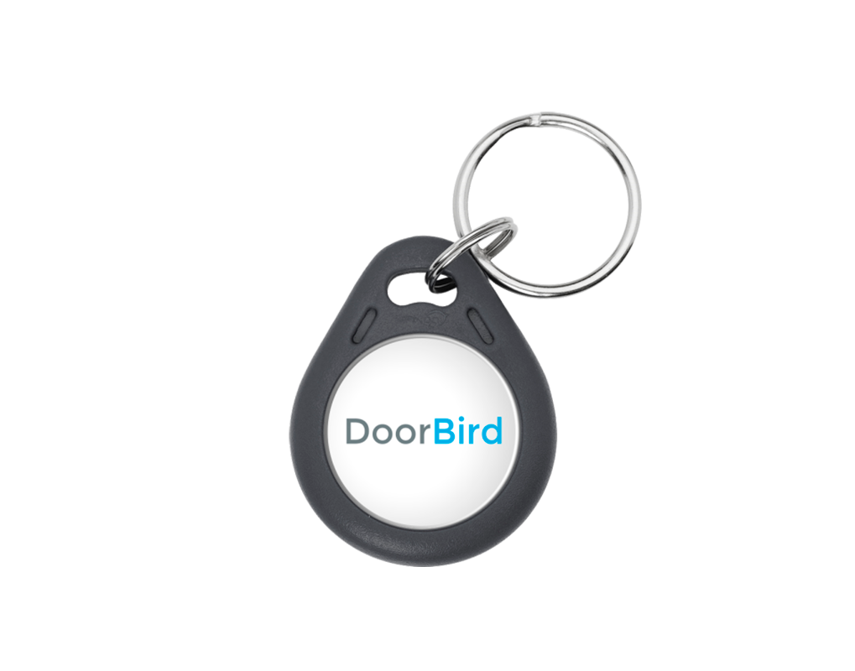

**Product Name**

Transponder Key Fob 125 KHz, 10 p.

**Product Description**

* For A1121 IP Access Control Device
* For D21x IP Video Door Stations and later
* 64 bit
* Write-protected
* Chip: TK4100
* Material: ABS, waterproof, grey
* 10 pieces

**Product Weight**

40 gm

**Delivery time**

Delivery within 6 business days!

**Often Ordered As Well**

* D2101V IP Video Door Station
* A1121 Flush-mount IP Access Control Device